--BUSINESS METRICS UNICORN

--What is the Revenue Growth Rate?

WITH revenue AS(

SELECT

EXTRACT(YEAR FROM o.order_date) AS Years,

SUM(od.order_sales) AS total_revenue

FROM customers c

JOIN orders o

ON c.customer_id=o.customer_id

JOIN order_details od

ON o.order_id=od.order_id

JOIN product p

ON od.product_id=p.product_id

GROUP BY Years

ORDER BY Years)

SELECT

years,

total_revenue,

COALESCE(LAG(Years) OVER(ORDER BY Years), 0) AS previous_Year,

COALESCE(LAG(total_revenue) OVER( ORDER BY years),0) AS total_revenue_in_previous_year,

CASE WHEN COALESCE(LAG(Years) OVER(ORDER BY Years), 0)!=0

THEN total_revenue-COALESCE(LAG(total_revenue) OVER( ORDER BY years),0)

ELSE 0 END AS yearly_revenue_diference,

CASE WHEN COALESCE(LAG(Years) OVER(ORDER BY Years), 0)!=0

THEN ROUND((total_revenue-COALESCE(LAG(total_revenue) OVER( ORDER BY years),0))/GREATEST(COALESCE(LAG(total_revenue) OVER( ORDER BY years),0),1)*100.00,2)

ELSE 0 END AS YoY_Revenue_Grouth_Rate

FROM revenue

ORDER BY years

;

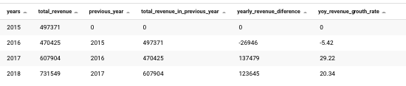

--Annual Recurring Revenue   
–(ARR) ARR = Monthly Recurring Revenue (MRR) × 12

--COSTS =REVENUE-PROFIT, REVENUE, PROFIT BY CUSTOMER

WITH revenue_per_customer AS(

SELECT

c.customer_id,

SUM(od.order_sales) AS total_revenue

FROM customers c

JOIN orders o

ON c.customer_id=o.customer_id

JOIN order_details od

ON o.order_id=od.order_id

JOIN product p

ON od.product_id=p.product_id

GROUP BY c.customer_id

),

costs AS (

SELECT

c.customer_id,

SUM(od.order_sales-od.order_profits) AS total_costs

FROM customers c

JOIN orders o

ON c.customer_id=o.customer_id

JOIN order_details od

ON o.order_id=od.order_id

JOIN product p

ON od.product_id=p.product_id

GROUP BY c.customer_id

),

profits AS (

SELECT

c.customer_id,

SUM(od.order_profits) AS total_profits

FROM customers c

JOIN orders o

ON c.customer_id=o.customer_id

JOIN order_details od

ON o.order_id=od.order_id

JOIN product p

ON od.product_id=p.product_id

GROUP BY c.customer_id

)

SELECT

r.customer_id,

r.total_revenue,

cc.total_costs,

pp.total_profits

FROM revenue_per_customer r

JOIN costs cc

ON r.customer_id=cc.customer_id

JOIN profits pp

ON cc.customer_id=pp.customer_id

ORDER BY r.customer_id

;

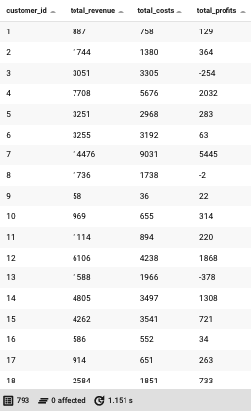

--COSTS =REVENUE-PROFIT, REVENUE, PROFIT YEARLY

WITH revenue_per_customer AS(

SELECT

EXTRACT(YEAR FROM o.order_date) AS Years,

SUM(od.order_sales) AS total_revenue

FROM customers c

JOIN orders o

ON c.customer_id=o.customer_id

JOIN order_details od

ON o.order_id=od.order_id

JOIN product p

ON od.product_id=p.product_id

GROUP BY years

),

costs AS (

SELECT

EXTRACT(YEAR FROM o.order_date) AS Years,

SUM(od.order_sales-od.order_profits) AS total_costs

FROM customers c

JOIN orders o

ON c.customer_id=o.customer_id

JOIN order_details od

ON o.order_id=od.order_id

JOIN product p

ON od.product_id=p.product_id

GROUP BY Years

),

profits AS (

SELECT

EXTRACT(YEAR FROM o.order_date) AS Years,

SUM(od.order_profits) AS total_profits

FROM customers c

JOIN orders o

ON c.customer_id=o.customer_id

JOIN order_details od

ON o.order_id=od.order_id

JOIN product p

ON od.product_id=p.product_id

GROUP BY Years

)

SELECT

r.Years,

r.total_revenue,

cc.total_costs,

pp.total_profits

FROM revenue_per_customer r

JOIN costs cc

ON r.Years=cc.Years

JOIN profits pp

ON cc.Years=pp.Years

ORDER BY Years

;

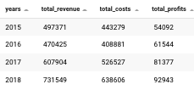

--KPIs: Profit per customer, Profit per product, Profit per month (YEARLY)

SELECT

c.customer_id,

SUM(od.order_profits) AS Profit_per_customer

FROM customers c

JOIN orders o

ON c.customer_id=o.customer_id

JOIN order_details od

ON o.order_id=od.order_id

JOIN product p

ON od.product_id=p.product_id

GROUP BY c.customer_id

ORDER BY Profit_per_customer DESC

;

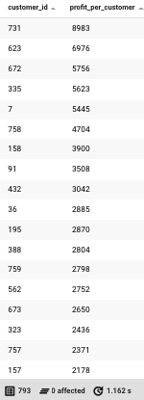

–Profit_per_product

SELECT

p.product_id,

SUM(od.order_profits) AS Profit_per_product

FROM customers c

JOIN orders o

ON c.customer_id=o.customer_id

JOIN order_details od

ON o.order_id=od.order_id

JOIN product p

ON od.product_id=p.product_id

GROUP BY p.product_id

ORDER BY Profit_per_product DESC

;

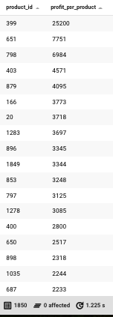

--Profit_per_Month

SELECT

EXTRACT(MONTH FROM o.order_date) AS month_number,

TO_CHAR(o.order_date, 'Month') AS delivr_month,

SUM(CASE WHEN EXTRACT(YEAR FROM o.order_date) = 2015 THEN od.order_profits ELSE 0 END) AS "2015",--Profit_per_Month

SUM(CASE WHEN EXTRACT(YEAR FROM o.order_date) = 2016 THEN od.order_profits ELSE 0 END) AS "2016",

SUM(CASE WHEN EXTRACT(YEAR FROM o.order_date) = 2017 THEN od.order_profits ELSE 0 END) AS "2017",

SUM(CASE WHEN EXTRACT(YEAR FROM o.order_date) = 2018 THEN od.order_profits ELSE 0 END) AS "2018",

SUM(CASE WHEN EXTRACT(YEAR FROM o.order_date) = 2019 THEN od.order_profits ELSE 0 END) AS "2019"

FROM customers c

JOIN orders o ON c.customer_id = o.customer_id

JOIN order_details od ON o.order_id = od.order_id

JOIN product p ON od.product_id = p.product_id

GROUP BY TO_CHAR(o.order_date, 'Month'),EXTRACT(MONTH FROM o.order_date)

ORDER BY month_number

;

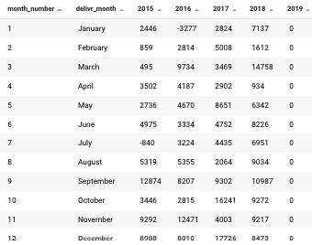

-SALES_per_Month

SELECT

EXTRACT(MONTH FROM o.order_date) AS month_number,

TO_CHAR(o.order_date, 'Month') AS delivr_month,

SUM(CASE WHEN EXTRACT(YEAR FROM o.order_date) = 2015 THEN od.order_sales ELSE 0 END) AS "2015",--SALES_per_Month

SUM(CASE WHEN EXTRACT(YEAR FROM o.order_date) = 2016 THEN od.order_sales ELSE 0 END) AS "2016",

SUM(CASE WHEN EXTRACT(YEAR FROM o.order_date) = 2017 THEN od.order_sales ELSE 0 END) AS "2017",

SUM(CASE WHEN EXTRACT(YEAR FROM o.order_date) = 2018 THEN od.order_sales ELSE 0 END) AS "2018",

SUM(CASE WHEN EXTRACT(YEAR FROM o.order_date) = 2019 THEN od.order_sales ELSE 0 END) AS "2019"

FROM customers c

JOIN orders o ON c.customer_id = o.customer_id

JOIN order_details od ON o.order_id = od.order_id

JOIN product p ON od.product_id = p.product_id

GROUP BY TO_CHAR(o.order_date, 'Month'),EXTRACT(MONTH FROM o.order_date)

ORDER BY month_number;

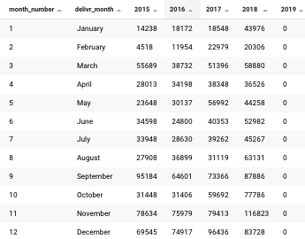

--ARPU V.S. Profit per customer

SELECT

c.customer_id,

ROUND(AVG(od.order_sales),2) AS ARPU,

ROUND(AVG(od.order_profits):: NUMERIC,2) AS average_profit_by_custimer,

CASE WHEN od.order_sales>0 THEN ROUND(od.order_profits ::NUMERIC/od.order_sales ::NUMERIC ,2) ELSE 0 END AS profit_ratio

FROM customers c

JOIN orders o ON c.customer_id = o.customer_id

JOIN order_details od ON o.order_id = od.order_id

JOIN product p ON od.product_id = p.product_id

GROUP BY c.customer_id,profit_ratio

ORDER BY ARPU DESC

;

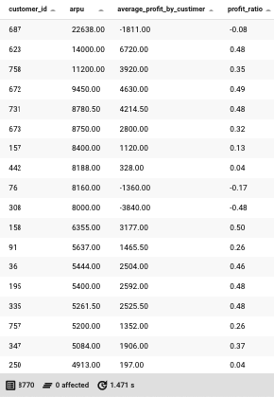

--Products_Profit

SELECT

p.product_name,

ROUND(AVG(od.order_sales),2) AS average_sales_per_product,

ROUND(AVG(od.order_profits):: NUMERIC,2) AS average_profit_by_product,

CASE WHEN od.order_sales>0 THEN ROUND(od.order_profits ::NUMERIC/od.order_sales ::NUMERIC ,2) ELSE 0 END AS profit_ratio

FROM customers c

JOIN orders o ON c.customer_id = o.customer_id

JOIN order_details od ON o.order_id = od.order_id

JOIN product p ON od.product_id = p.product_id

GROUP BY p.product_id,profit_ratio

Order by profit_ratio ASC

;

